**Assignment Questions:**

***(Topics: find, grep, sort, awk, cut, paste, sed)***

1. Write a command to find all .txt files in the current directory.

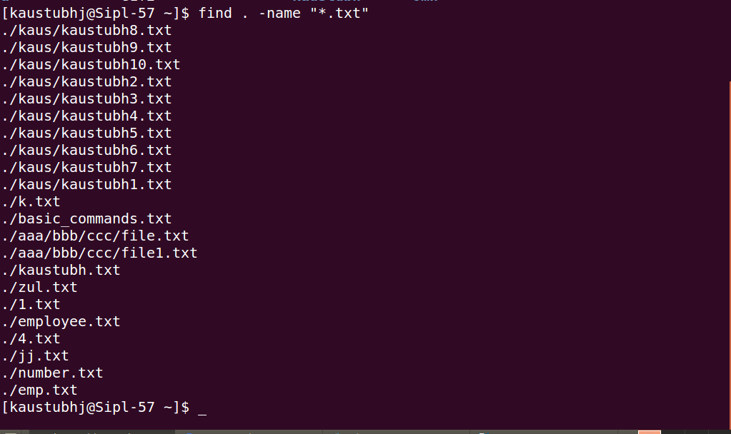

1. Write a command to show long listing ( ls – lids ) for all file with extension .c



1. Write a command to find files with inode number 2



1. Write a command to find all file with permission 777



1. Write a command to find file that have modified in less than two days

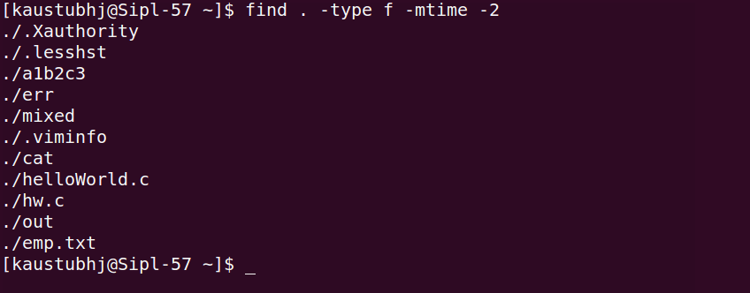

1. How do you search for files larger than 10kb in the /var/log directory?

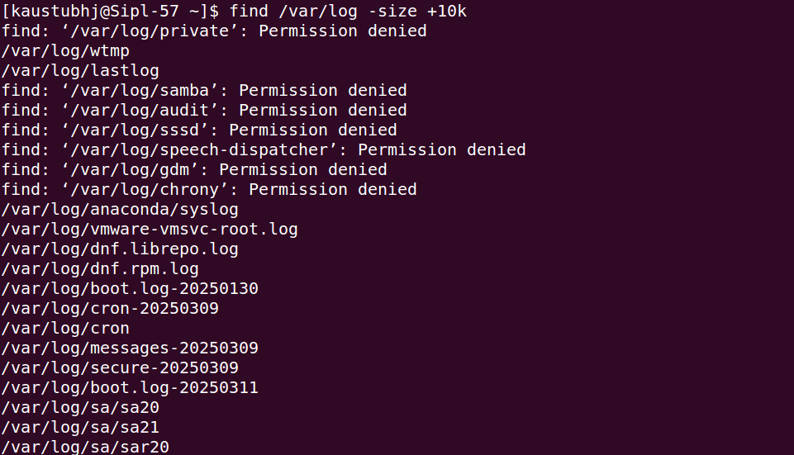

1. Find all files modified in the last 7 days inside /home/user.

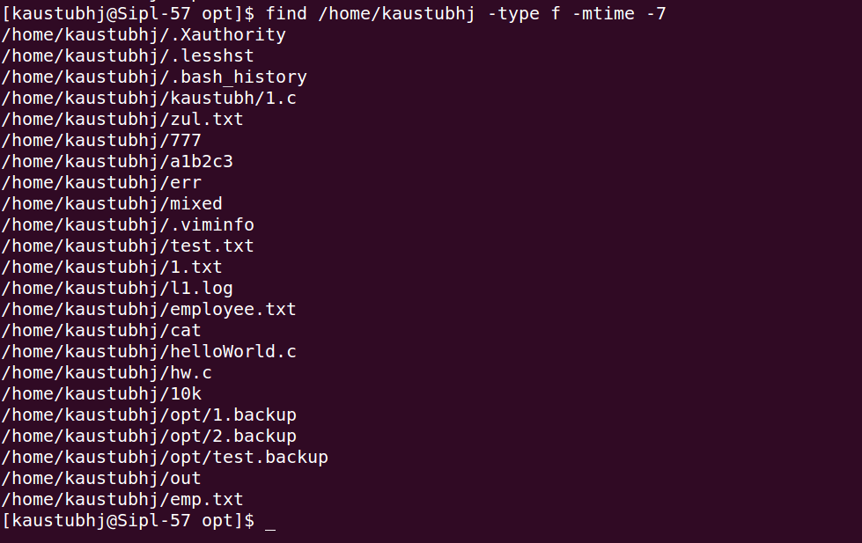

1. Search for all empty files inside /tmp.



1. How can you find and delete all .log files inside /var/tmp?

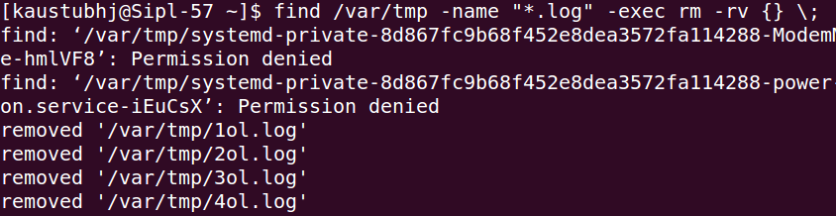

1. Write a command to locate all directories named backup under /opt.



1. How do you find all files owned by the user <user-name> in /home?

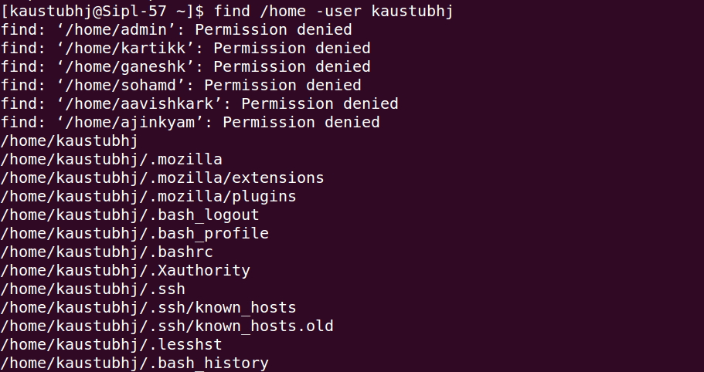

1. Find all executable files in /usr/bin.

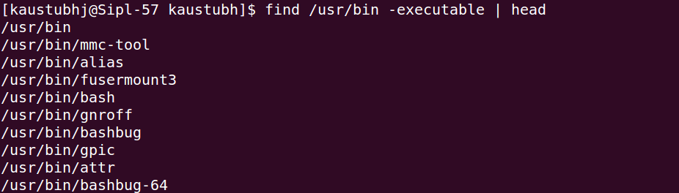

1. How do you combine find with grep to find all files

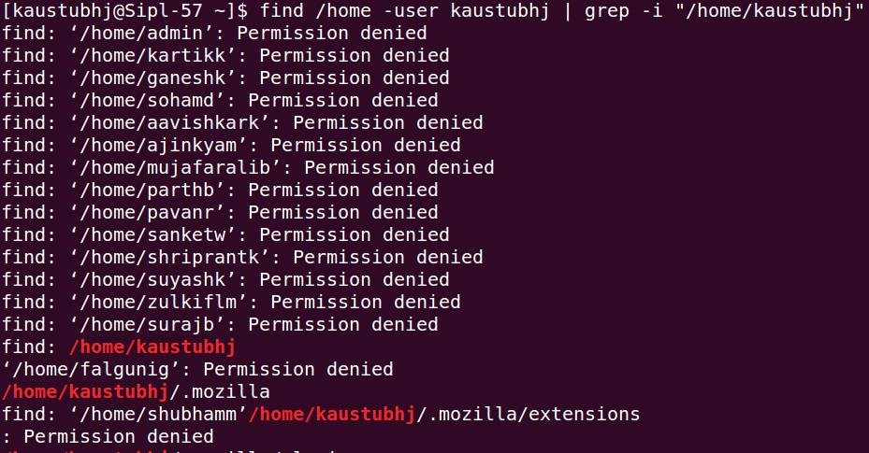

1. remove all ordinary file with that are not accessed for more than 365 days. Confirm before removing

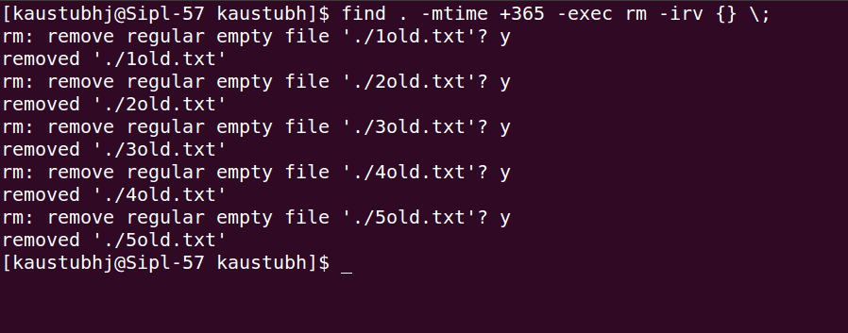

1. Find all lines containing a specific word



1. Search for multiple words

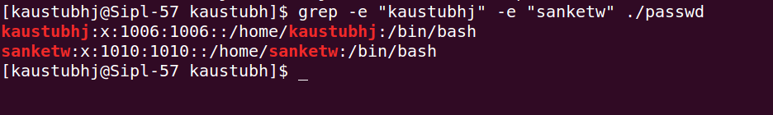

1. Display line numbers for matches



1. Search in multiple files

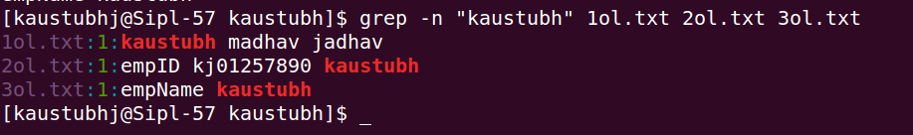

1. Search recursively in directories



1. Display only matching words



1. Exclude lines matching a pattern

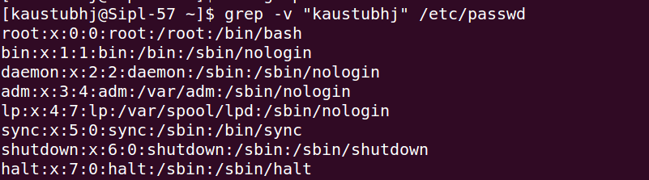

1. Search for a pattern at the start of a line

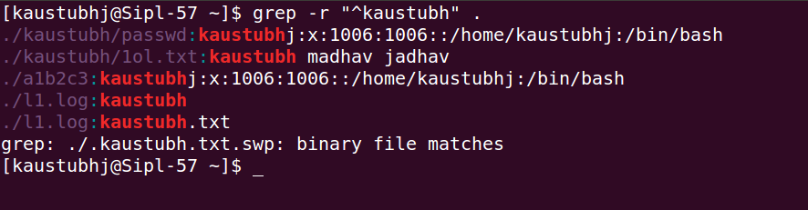

1. Display lines with context



1. Count occurrences of a word



1. How do you sort a file alphabetically?



1. Sort a file in reverse order.



1. Sort a list of numbers in ascending order.



1. Sort a file and remove duplicate lines.



1. How do you sort a file by the second column?



1. Sort a text file based on numeric values.



1. How do you ignore case while sorting?

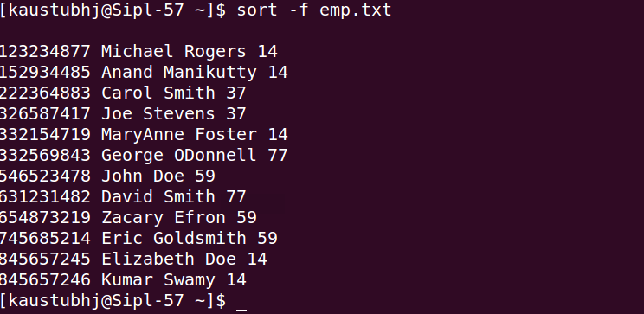

1. Sort a list of IP addresses numerically.

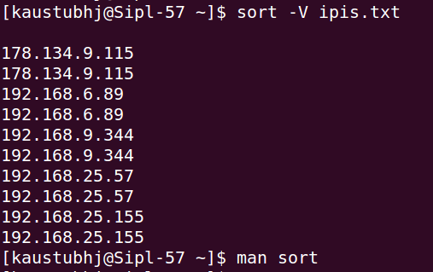

1. Sort /etc/passwd based on the third field (UID).

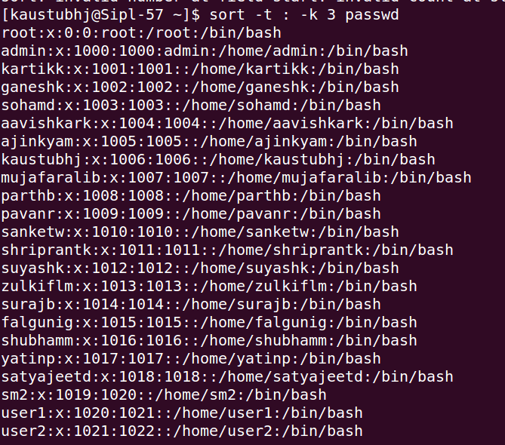

1. Sort a file but keep its original order for duplicate entries.

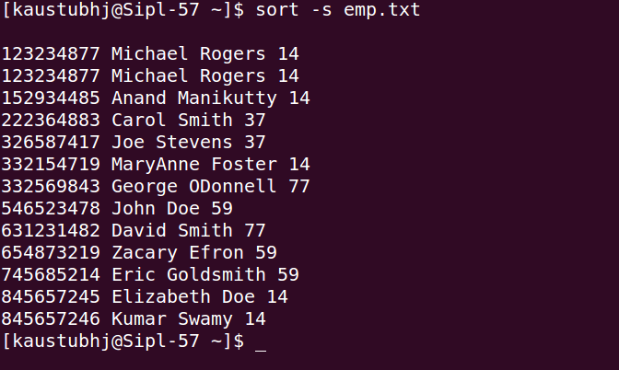

1. Print the first column of a file.

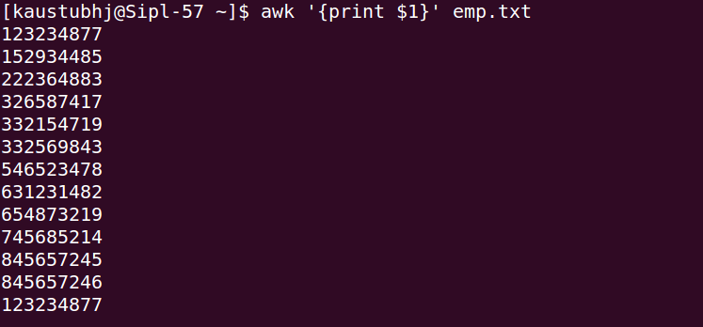

1. Extract the second and fourth columns from /etc/passwd.

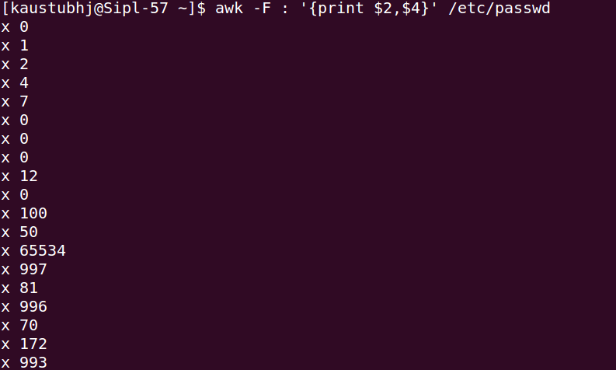

1. Print all lines where the third field is greater than 1000 in /etc/passwd

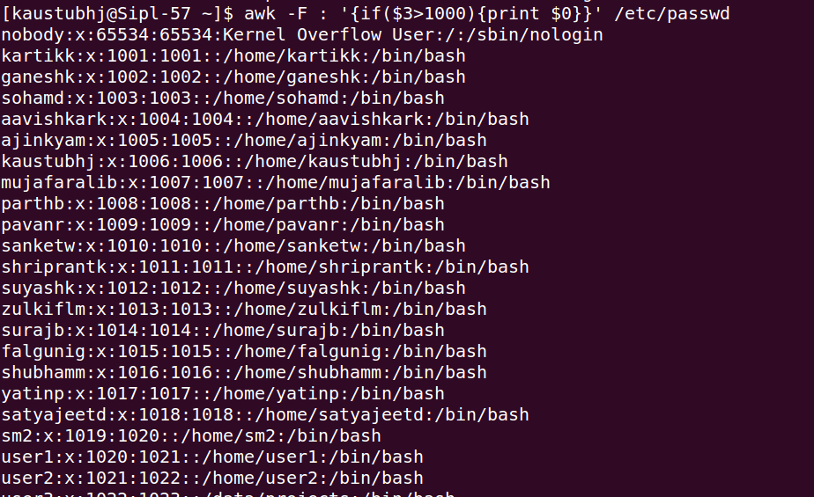

1. Count the number of lines in a file using awk.fd



1. Print the number of times each unique word appears in a file.
2. Extract the usernames from /etc/passwd and display only those with UIDs above 1000.

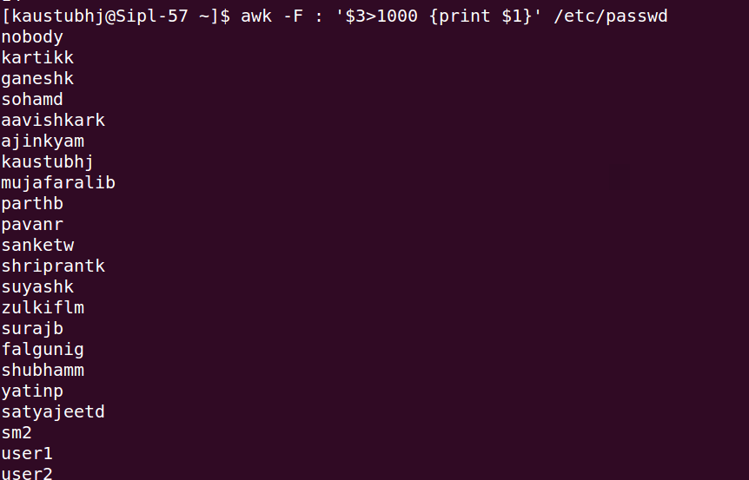

1. Format and print the output: "User [username] has UID [UID]" from /etc/passwd.

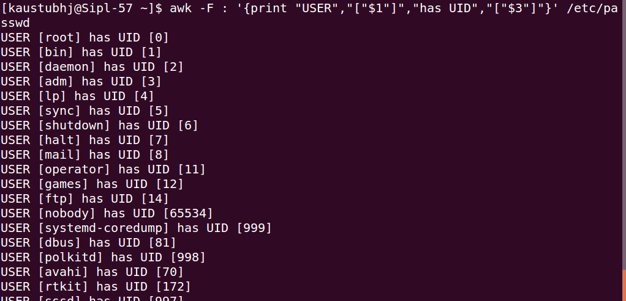

1. Extract only the first column from <file>.

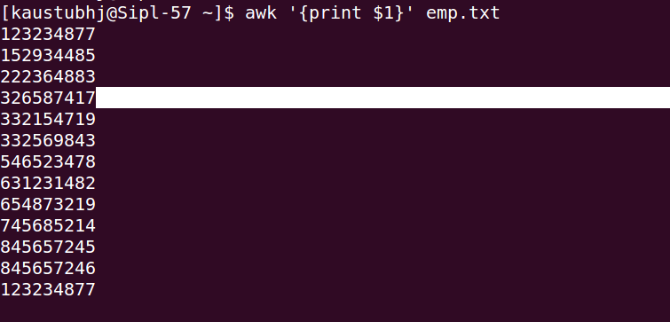

1. Merge file1.txt and file2.txt side by side.



1. Replace all occurrences of "apple" with "orange" in fruits.txt.

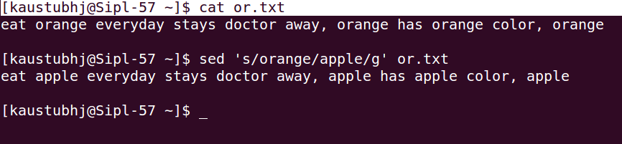

1. Merge two files (file1.txt and file2.txt) side by side, separating columns with a tab.

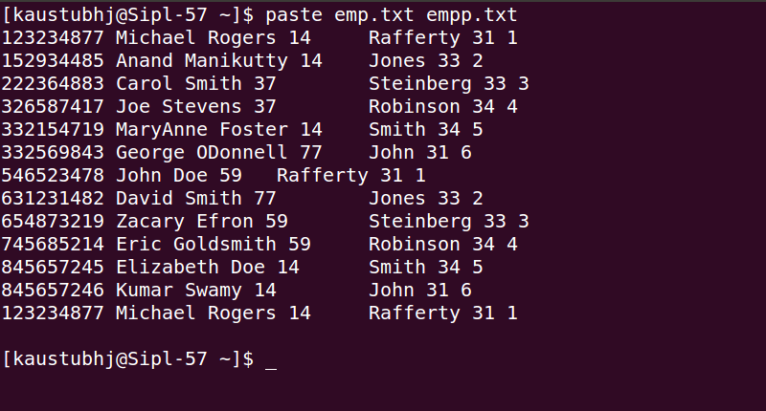

1. Combine names.txt and ages.txt into a new file called merged.txt.

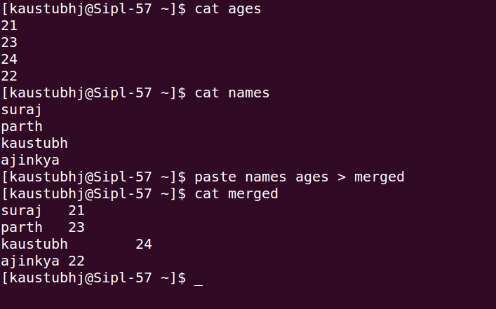

1. Merge three files (students.txt, marks.txt, and grades.txt) into one.

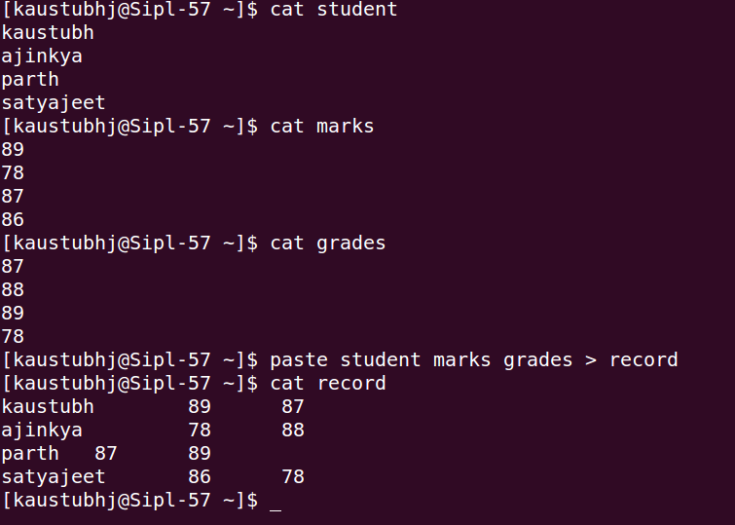

1. Display the first three columns from file1.txt and merge it with file2.txt.

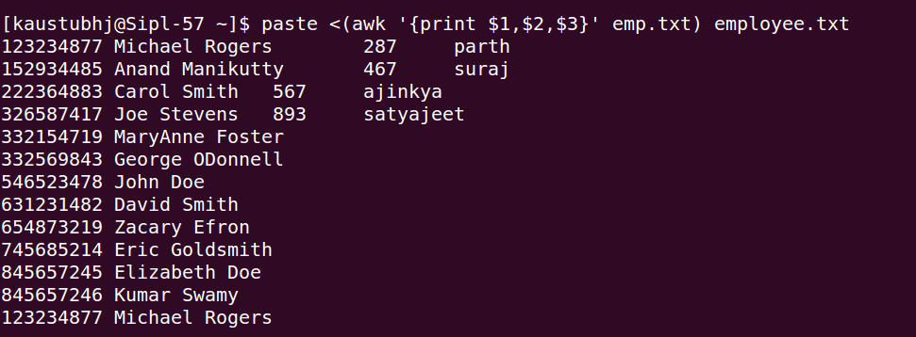

1. Merge two files, data1.txt and data2.txt, but display the output **vertically instead of side by side**.

